**9. ReactJS-HOL – Documentation**

**Objective :**

* Use map() method of ES6
* Apply arrow functions of ES6
* Implement Destructuring features of ES6

**Prerequisties :**

The following is required to complete this hands-on lab:

* Node.js
* NPM
* Visual Studio Code

**Project Folder Name :**

Cricketapp

**Application Components**

1. ListofPlayers

- Stores an array of 11 cricket players with scores.

- Uses ES6 map() to display all players.

- Uses ES6 arrow functions to filter out players scoring below 70.

2. IndianPlayers

- Splits players into Odd and Even teams.

- Demonstrates ES6 destructuring to access specific elements.

**Procedure :**

(Follow up the steps given in hands on)

**Output Snapshot :**

* When Flag = True

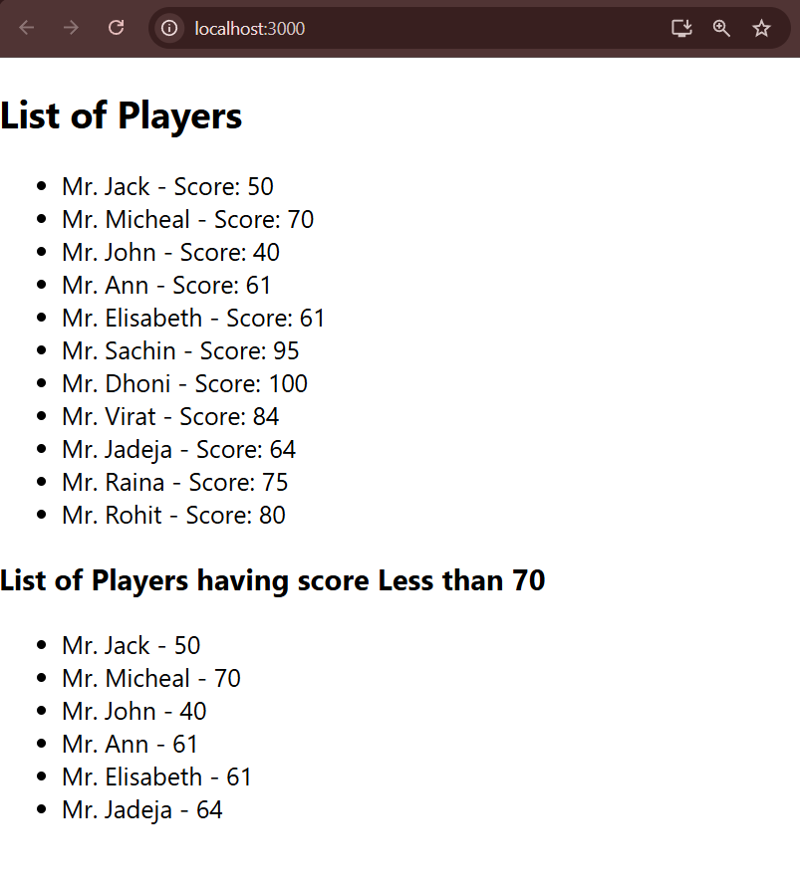

* When Flag = False

